DEMONSTRATIVE PNEUMATIC

STAND

*BIBUS TECHNOLOGIES*

Prof. Coordinator Ghinea Mihai

Students Setelecan Mircea Setelecan Theodor

**CONTENTS**

1. General view and description of machine functionalities
2. Technical data and parts specifications
3. Aspects of automatization
4. Detailed presentation of the equipment

## General view and description of machine functionalities

This is a demonstrative equipment made for gaining access to data in coordinate movement of the stepper motor, transmission and pneumatic pistons.

The stand it’s activated by the green button (1).

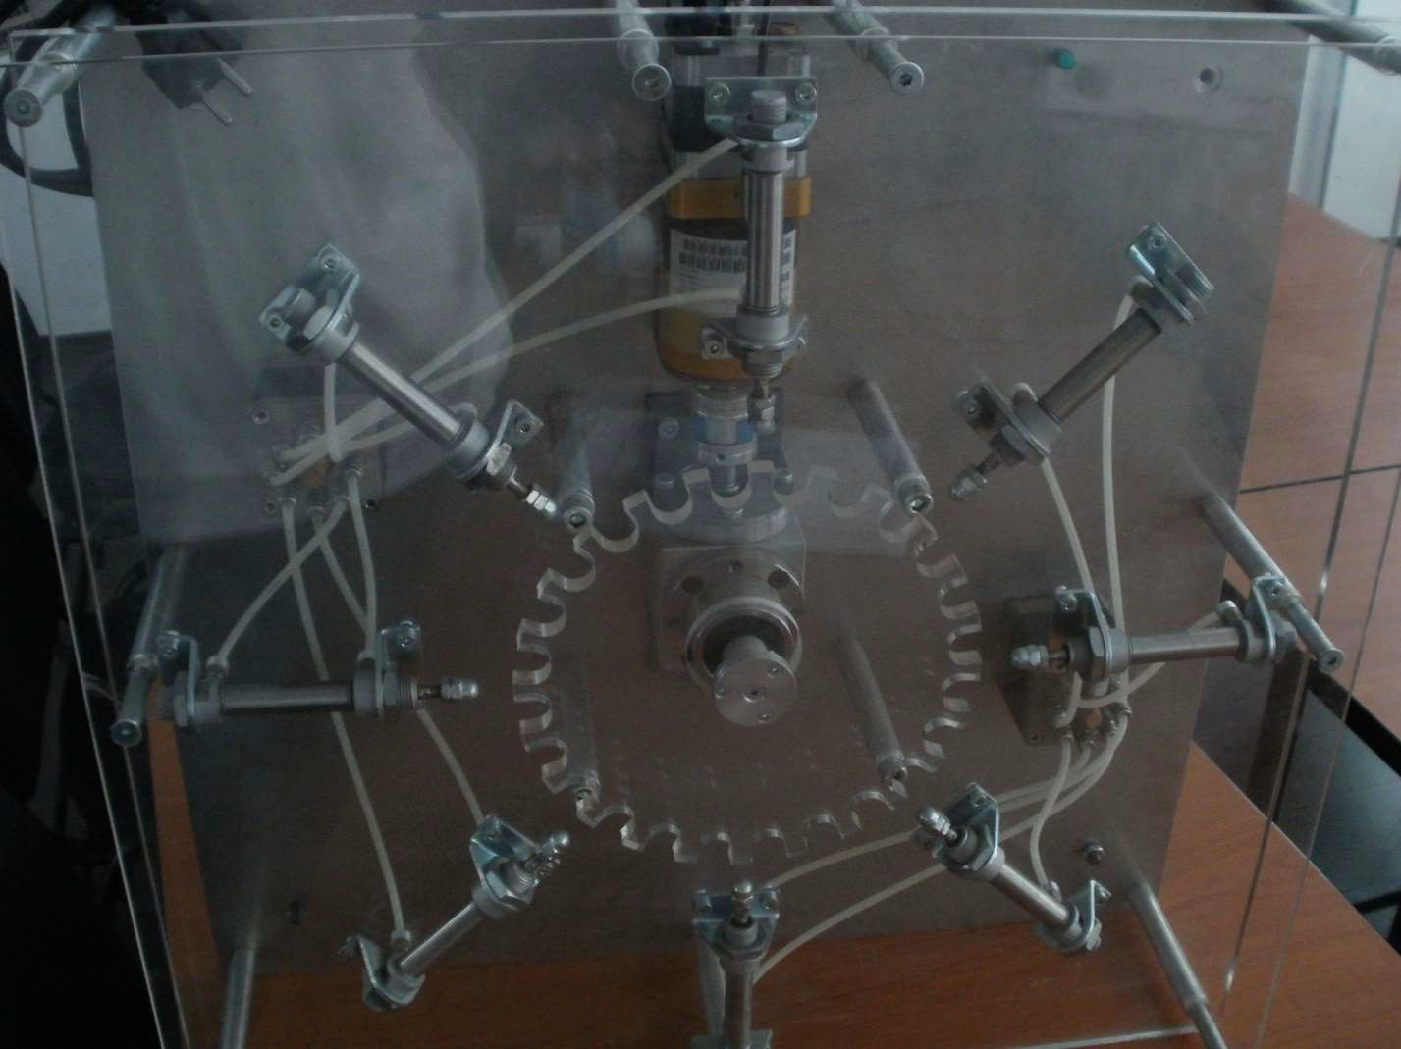

***7***

***1***

***8***

***20***

***6***

F.1- Pneumatic stand – Front view

The device is powered by a Moeller 400POW (2) power source. The data is converted and is directed by a Moeller3- EASY621-DC-TC (3) in module and a Moeller 2- EASY821-DC-TCX

(4) out module, which generates signals to the pneumatic sensor (5), where the pressure is verified and the solenoid valves-matrix (6), (7) and (8).

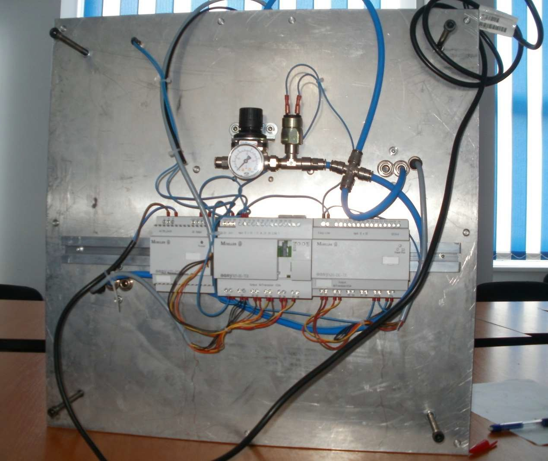

**5**

**3**

**4**

**2**

F. 2- Pneumatic stand – Rear view

Valves (6) and (7) perform concomitant pneumatic control that generates the linear motions of pistons (10) to (17).

**10 …17**

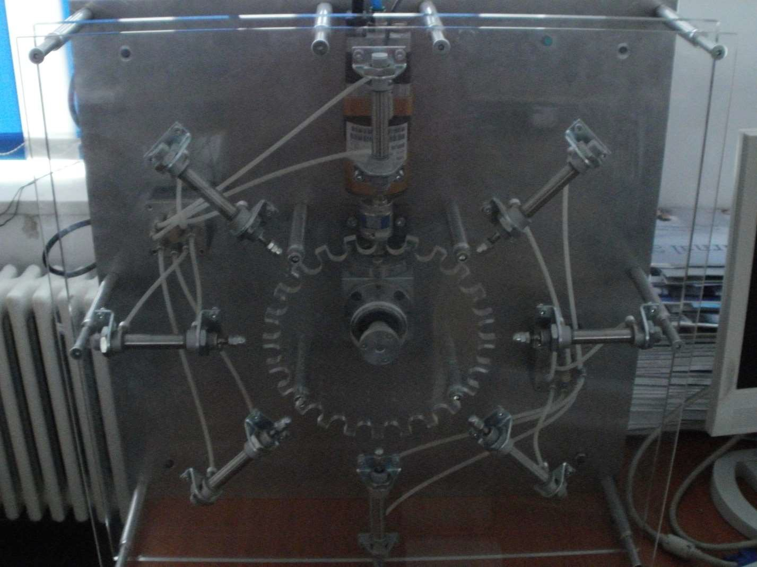

F.3

Another solenoid valve is used to control the stepper motor (9), which is connected to a flexible coupling (18) that engage the bevel gear (19).

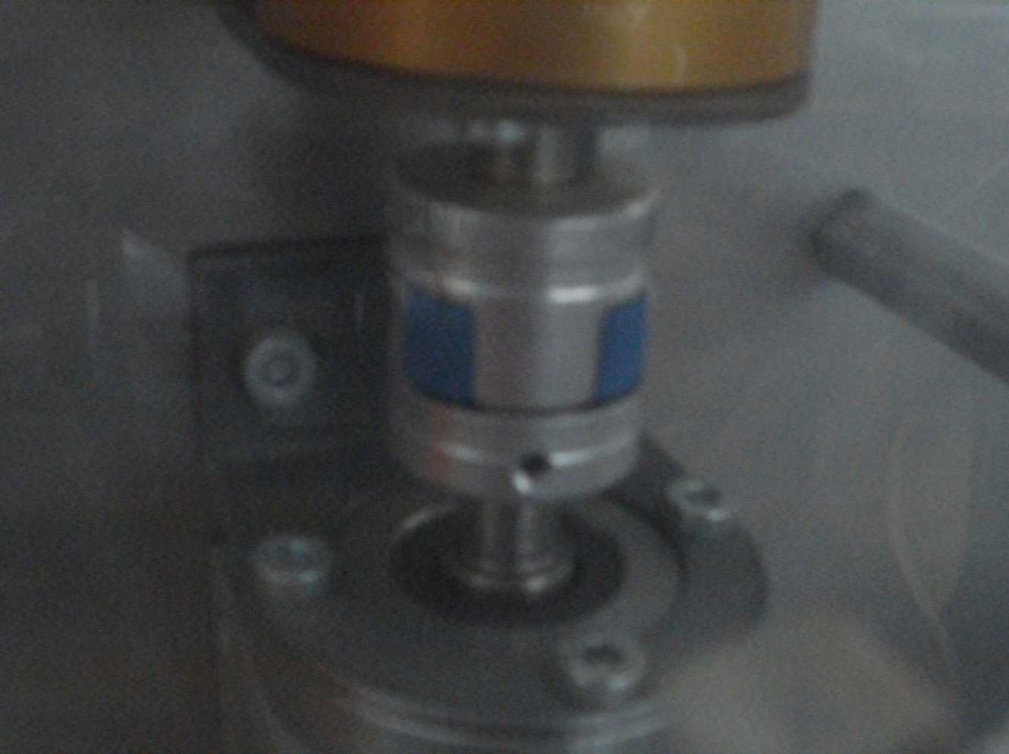

**9**

**19**

**18**

F.4

The purpose of this equipment is to demonstrate the capability of every part to work at a maximum performance in cooperation with the others. In the image below are represented the motion parts of this machine: motor, coupling, bevel gear that changes the motion angle, plastic wheel and pneumatic pistons. To verify the all of the parts that work together the piston’s heads should enter between the wheel’s teeth without touching them.

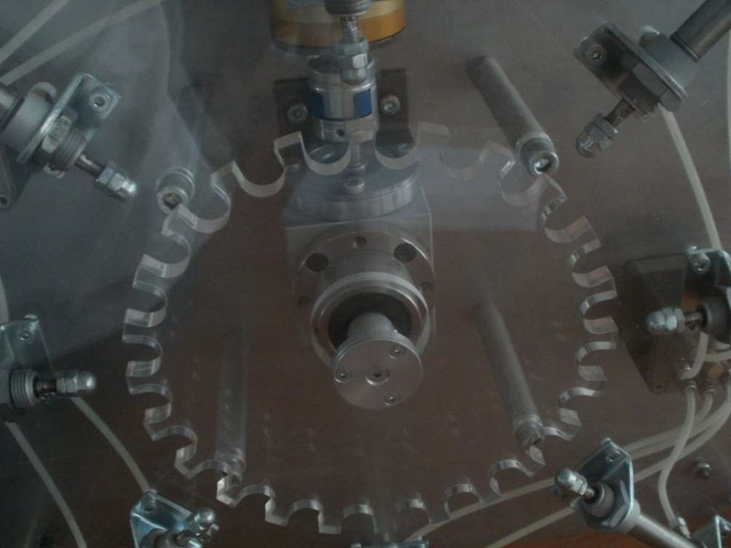

F.5- Motion parts

## Technical data and parts specifications

Solenoid Valve Matrix 758

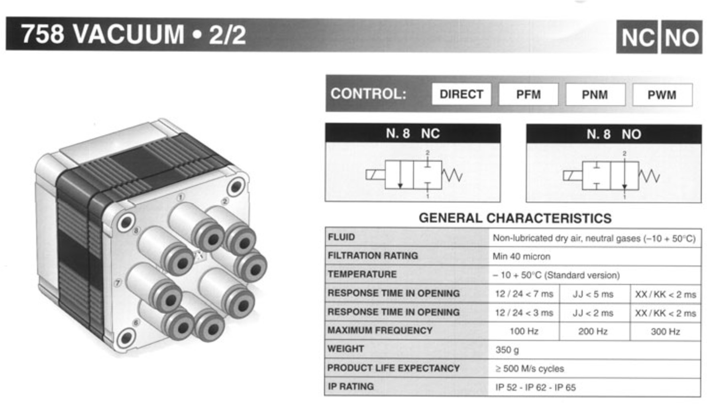

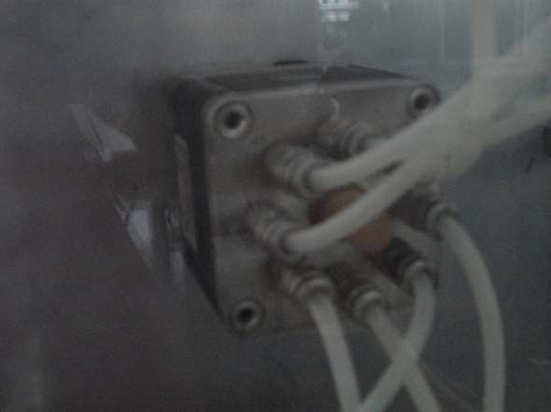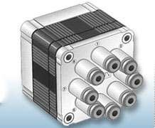

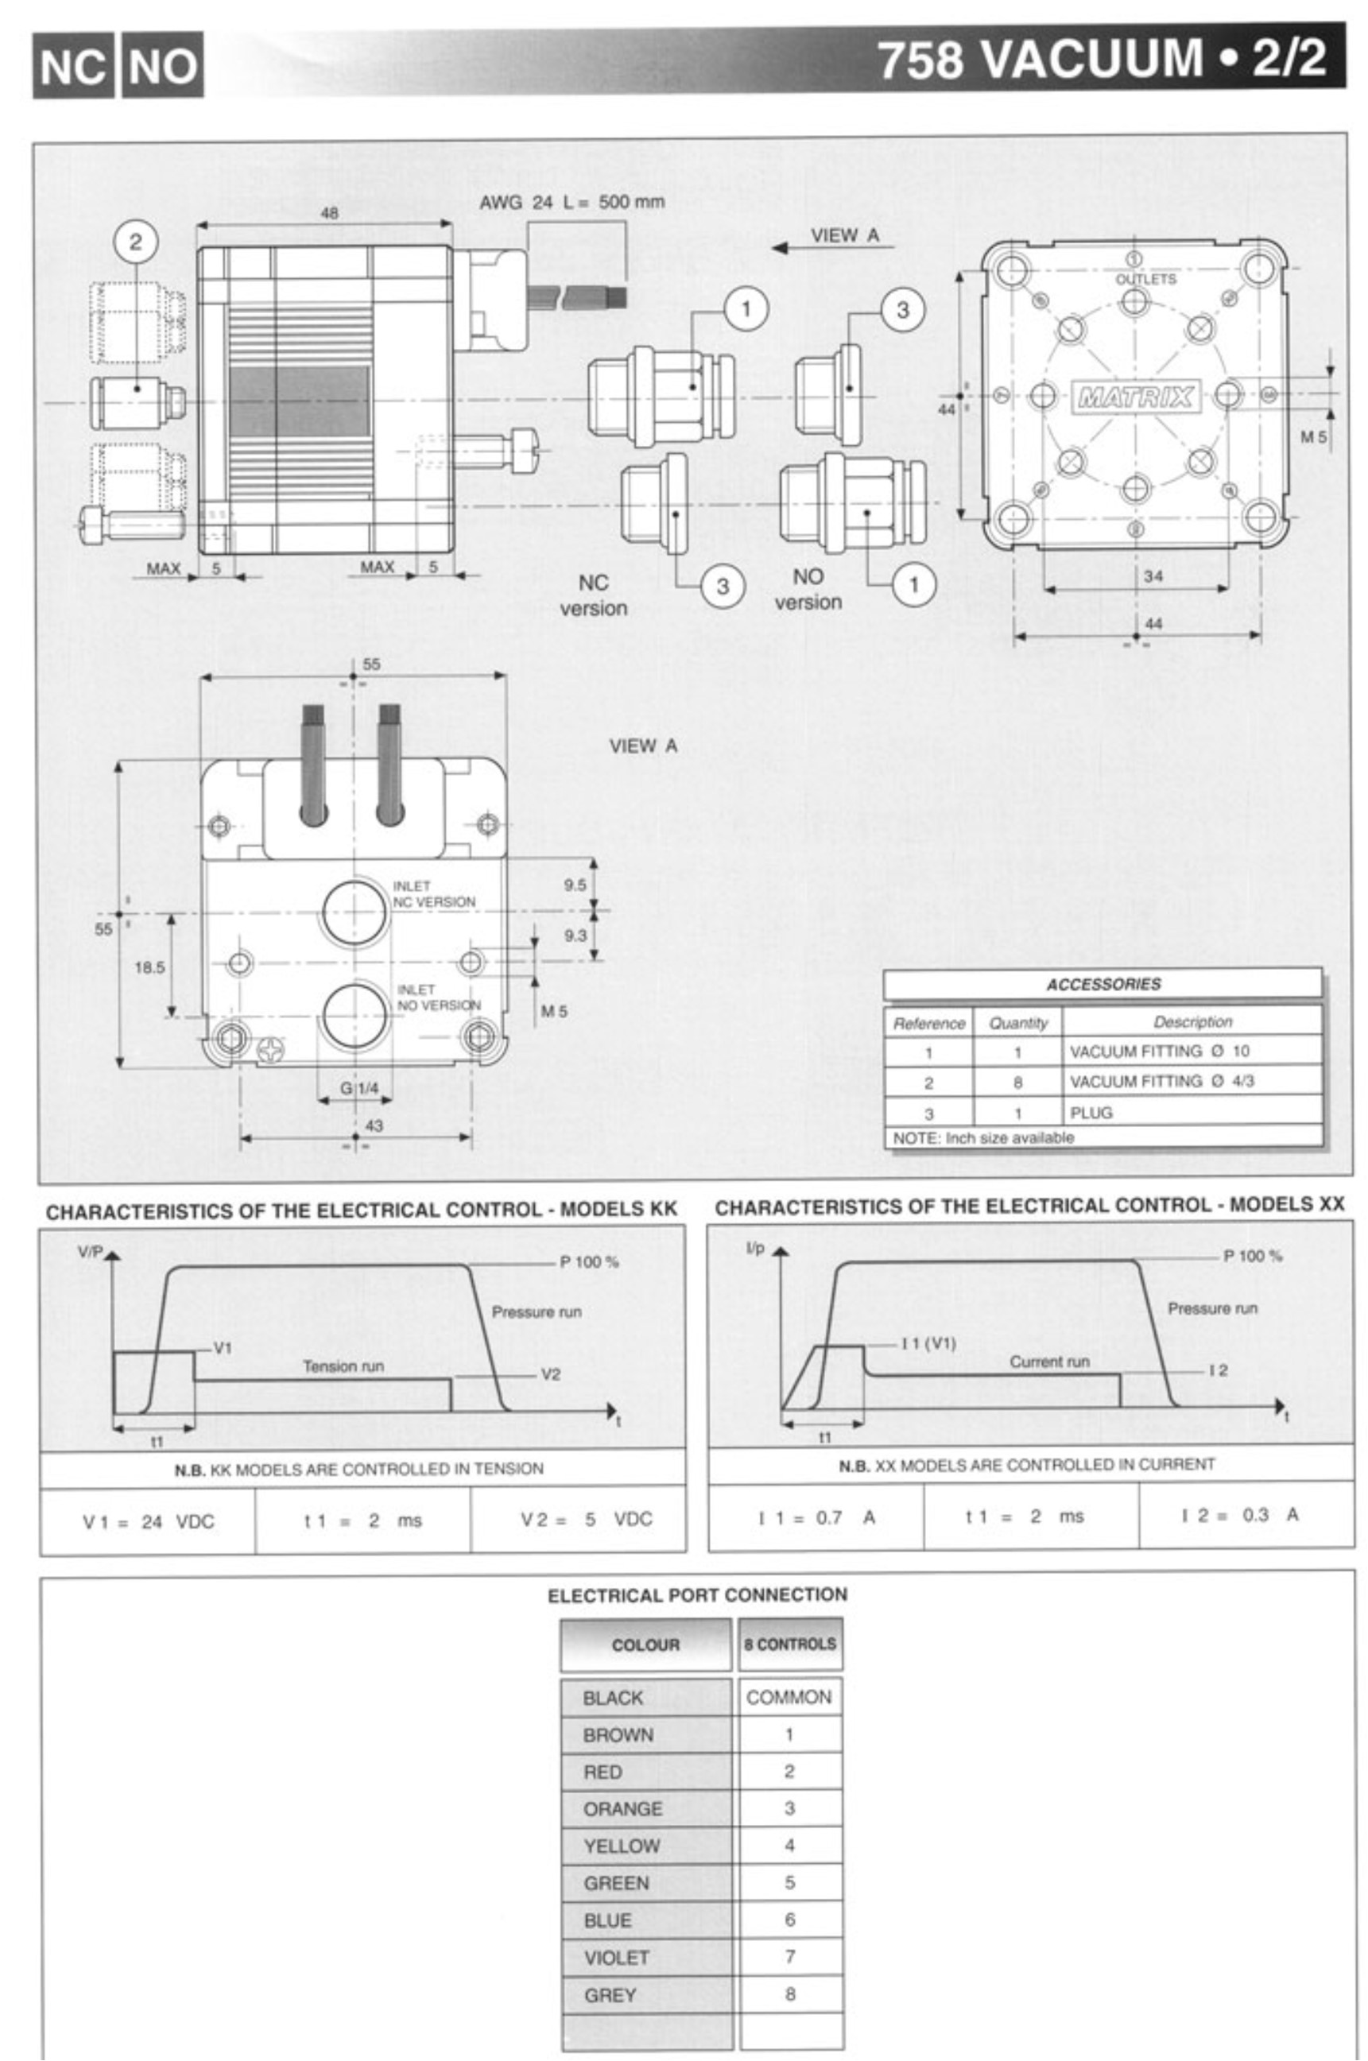



# Motor

**BPS-1620-MX Stepping** motor with 3.3 Nm,

shaft end, key groove, spring and with Matrix valve

##### Product characteristics

* Compact motor / valve unit
* Up to 10 Nm torque
* Protection class: IP 55

Technical Information

The pneumatic stepper motor offers several advantages over electric versions. High torques is achieved even with small dimensions and without a reduction gear thanks to the pneumatic drive. All pneumatic stepper motors are equipped with internal braking – with no step loss – in case of a power failure. This is a decisive advantage particularly for sensitive applications. The flange-mounted valve provides for a very compact unit without additional hose connections. These pneumatic stepper motors are used wherever precision under difficult conditions is demanded. In dusty or dirty environments or in the presence of strong magnetic fields as well the pneumatic stepper motor really shows its strengths. The motor features versatile and simple control and there is a suitable type for every application, e.g. classic with an output shaft or with a spindle for linear motions.

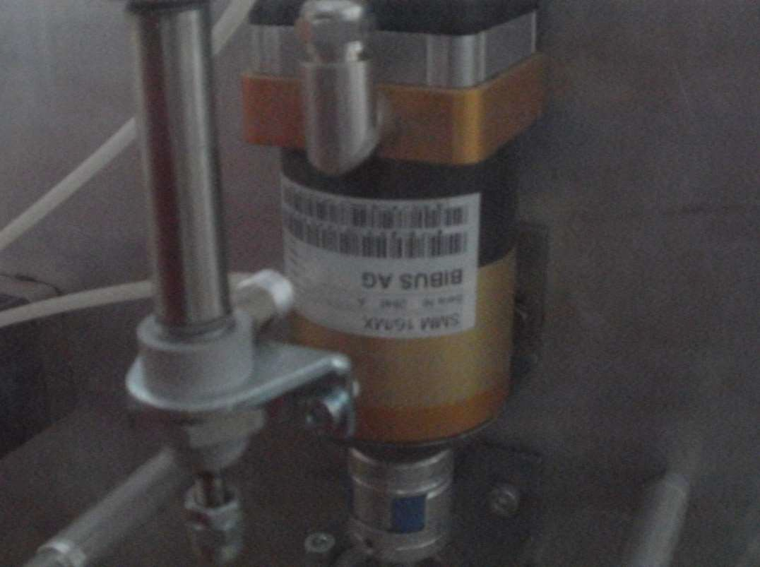

# Bevel gear

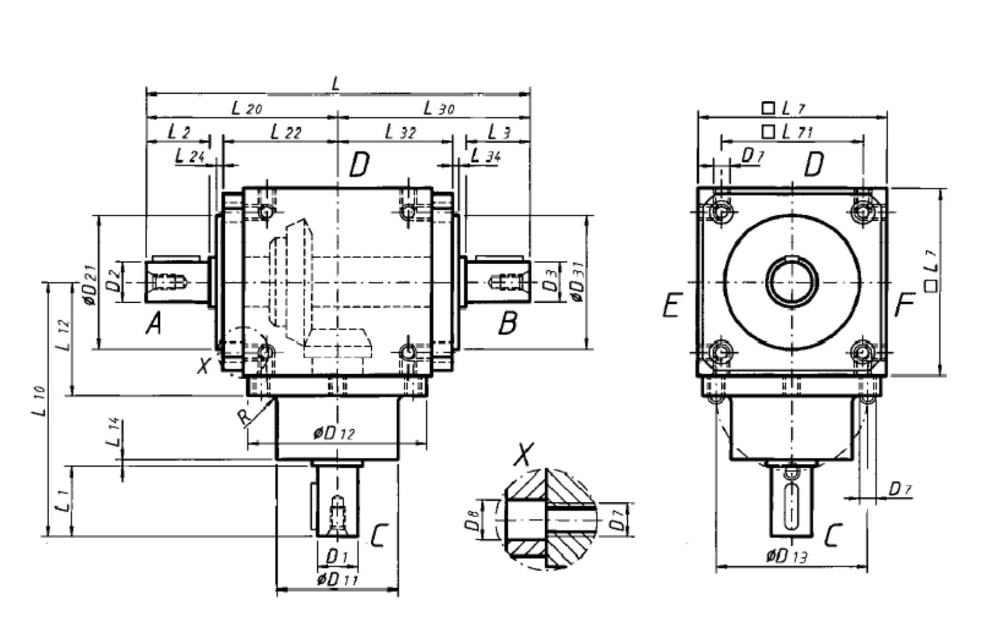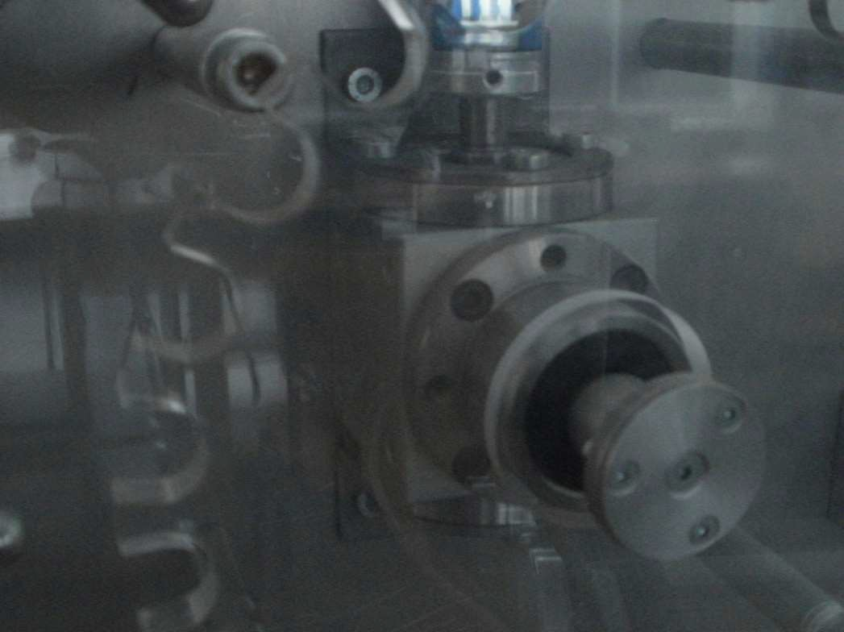

**Flexible couplings RA, RG**

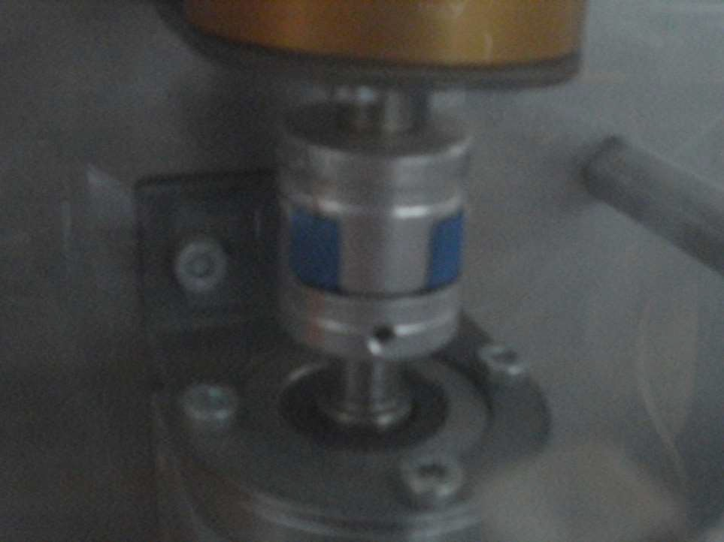

Flexible couplings transmit the torque by positive locking, and compensate for slight nonalignment, stagger and offset of shafts.

Standard toothed ring 92 Shore A.



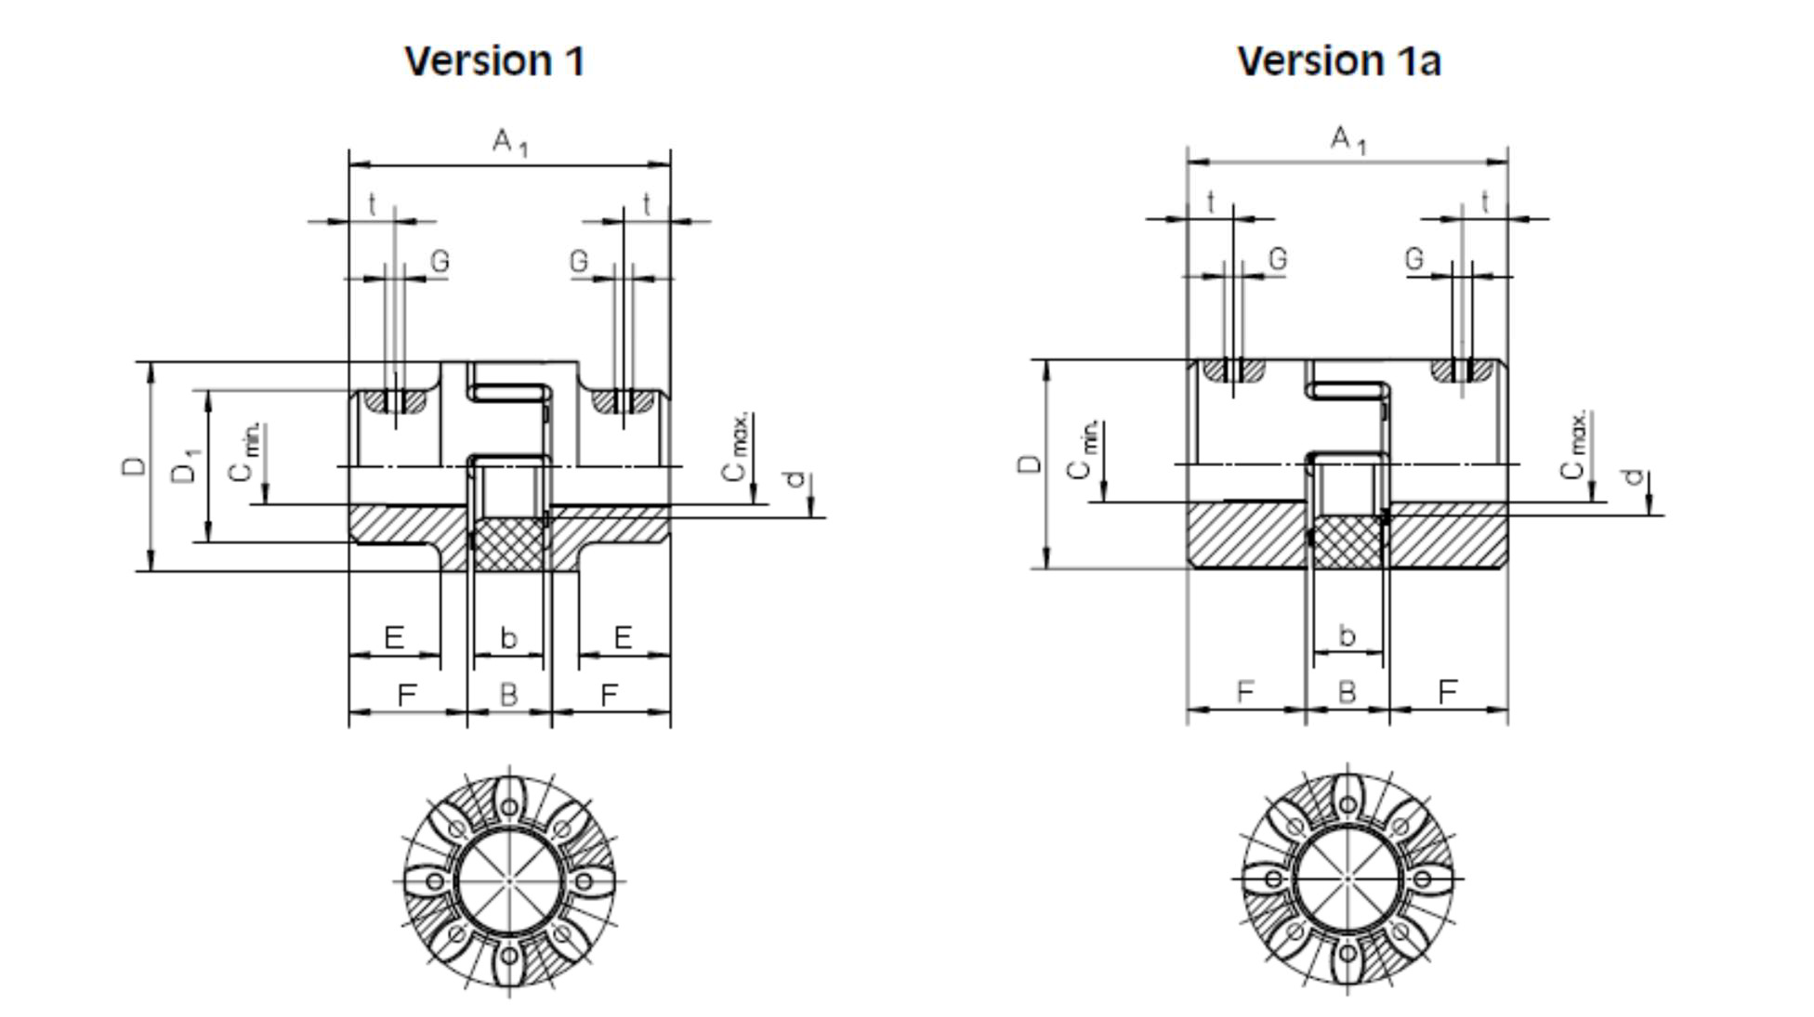

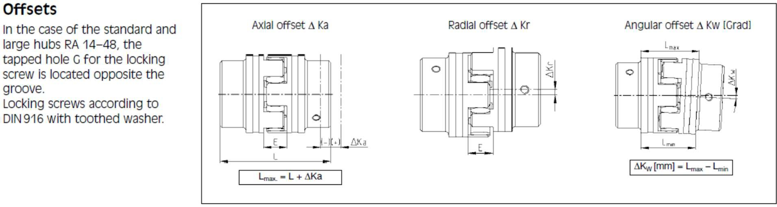

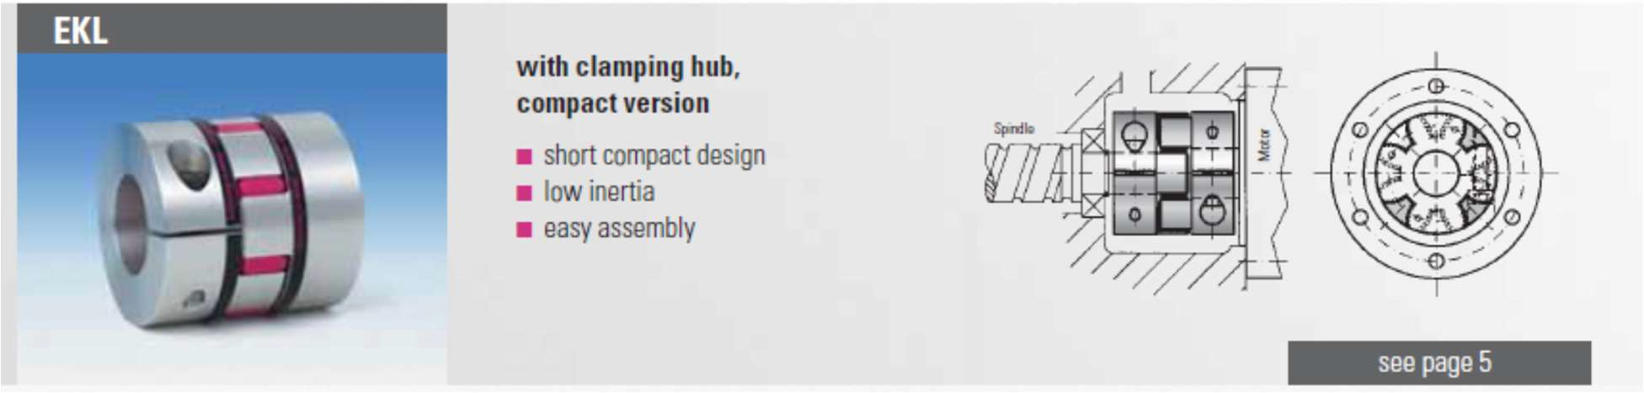

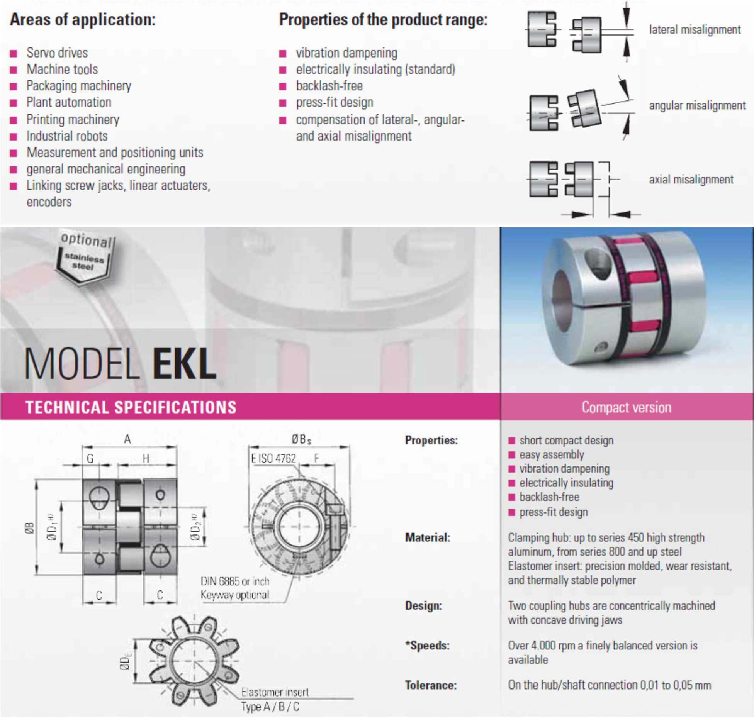

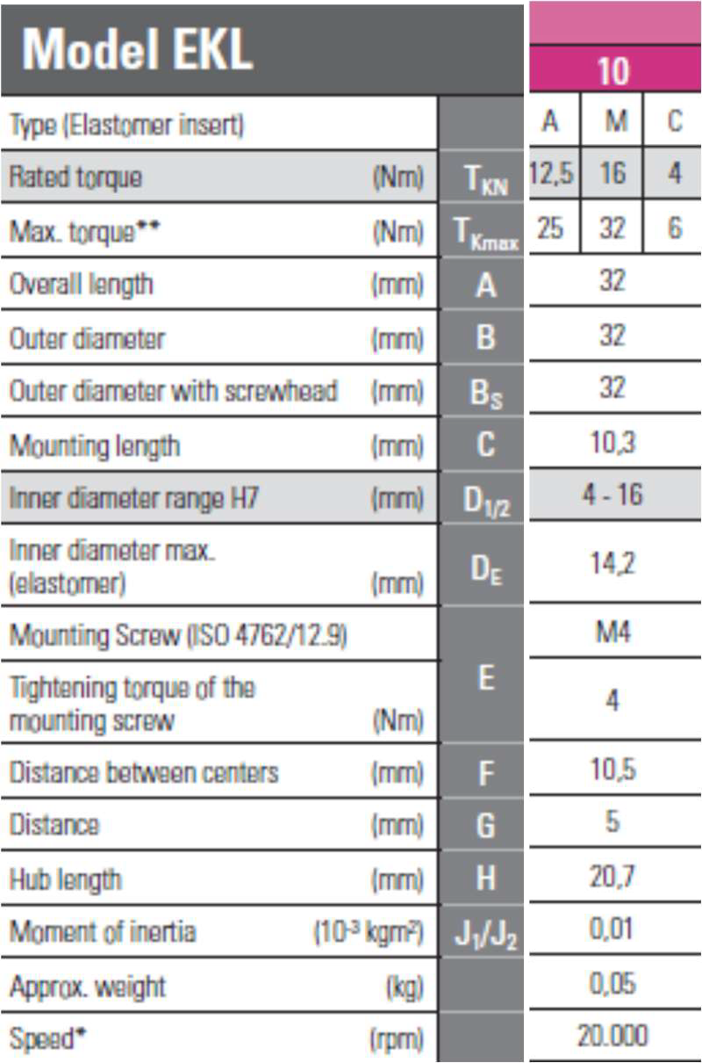

#### Moeller 1-EASY400-POW

##### Switched-mode power supply unit

Input voltage range: 85 to 264 V Output voltage: AC 24 V DC +/- 3% Output current, nominal value: 1.25 A Overcurrent limitation from 1.4 A

Potential isolation, primary/secondary: Yes, SELV(to EN 60 0950, VDE 805) Short-circuit proof (secondary): Yes

Overload protection (secondary): Yes

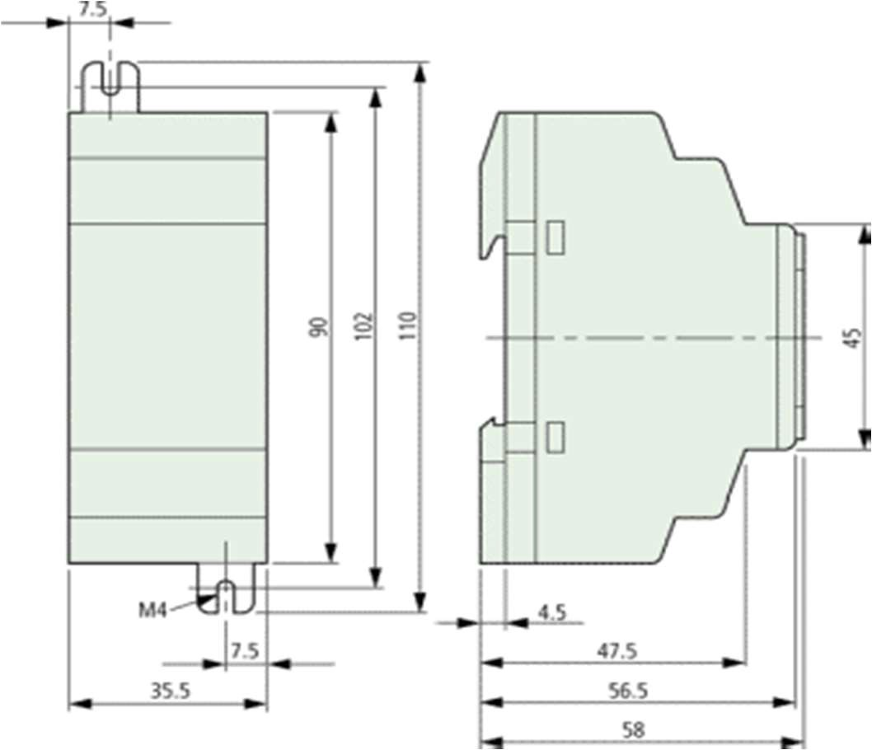Dimensions (W x H x D) inches: 1.39 x 3.54 x 2.28 inches

#### Moeller 2- Easy 825-DC-TCX

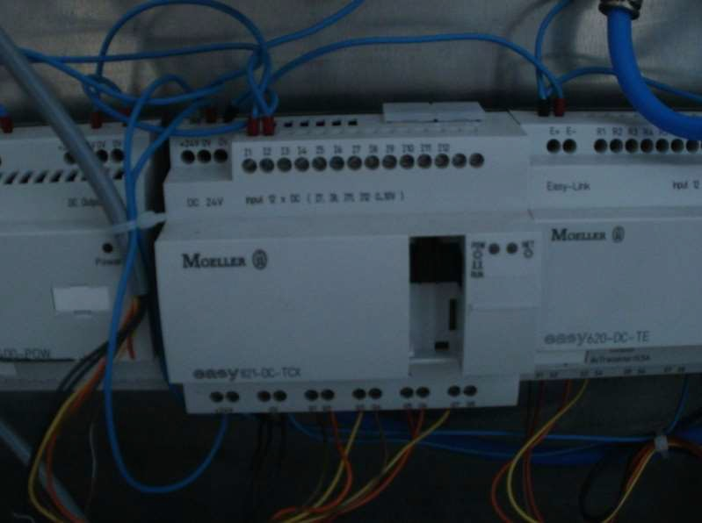

Supply voltage: 24 VDC Power dissipation: 3.4 W Inputs, digital: **12**

Inputs, analog, option (0–10 V): Up to **4** of the provided **12** inputs may be user assigned as analog inputs

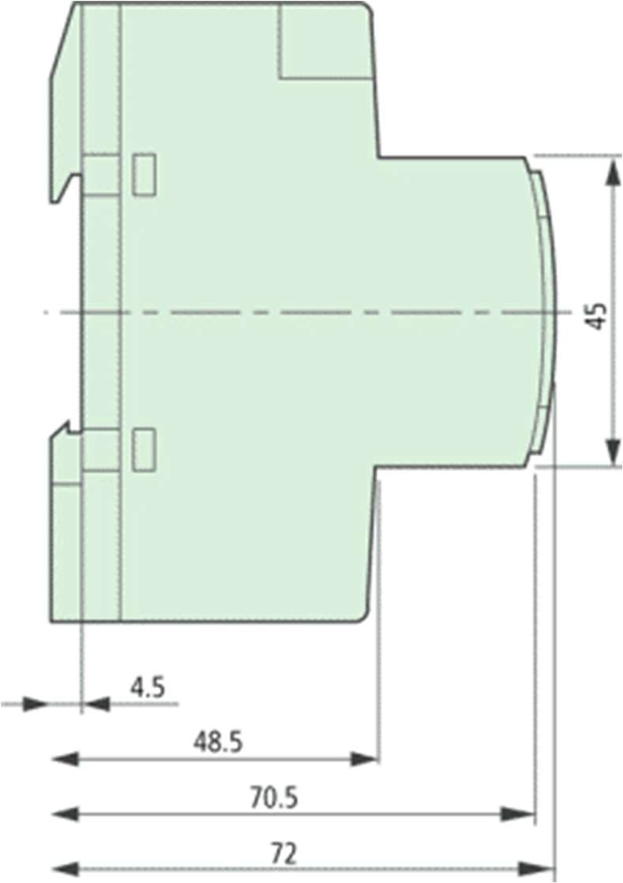Outputs: **8** *Transistors*

Outputs, analog,(0–10 V): -

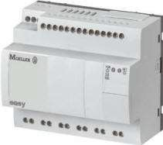

**Moeller3- EASY621-DC-TC**

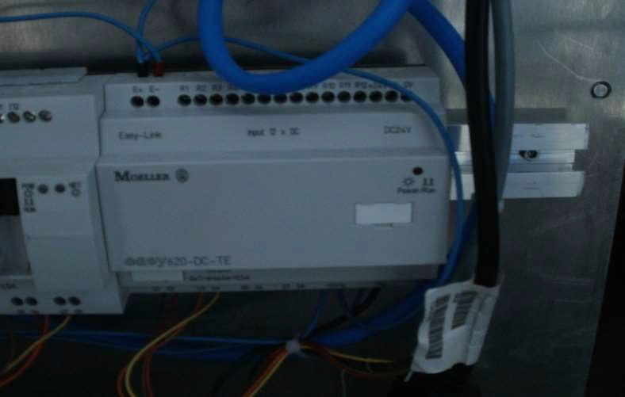

Supply voltage: 24 VDC Power dissipation: 4 W Inputs, digital: **12**

Inputs, analog, option (0–10 V): *Up to* ***2*** *of the provided* ***12*** *inputs may be user assigned as analog inputs*

Outputs: 6 *Relay*

Outputs, analog, (0–10 V): Not Available LC display, keypad/keypad EASY: Yes Week/Year clock: Yes/--

Output continuous current: 0.50 A

Short-circuit proof at cos phi = 1: Line protection B 16, 600 A

Short-circuit proof at cos phi =0.7 0.7: Line protection B 16, 900 A

Dimensions in inches (W x H x D): 4 x 3.5 x 2.3 in.

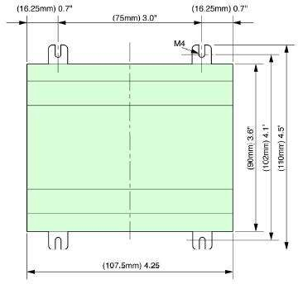

### M3A-ABS 40

Case: Black plastic Transparent plastic Quadrant: White plastic

Element gauges: Bourdon tube in copper alloy, solder alloy of tin

_ C 60 bar spring,

_ 60 bar spring curl Movement: Brass Specifications

Reference standards: EN 837-1 Pressure: Static: 75% of full scale Floating: 60% of full scale

For short periods: up to full scale Temperature Limits: Ambient: -20 ... +60 ° C Fluid: +60 ° C maximum

Storage: -20 ... +60 ° C

Thermal drift: ± 0.04% / 1K compared to (+20 ° C) Accuracy class: cl. 2.5, cl. 1.6 to request

UNIVERSITY “POLITEHNICA” of BUCHAREST

Degree of protection: IP 31 to EN 60 529 / IEC 529

*Individual weight: 0,048 kg 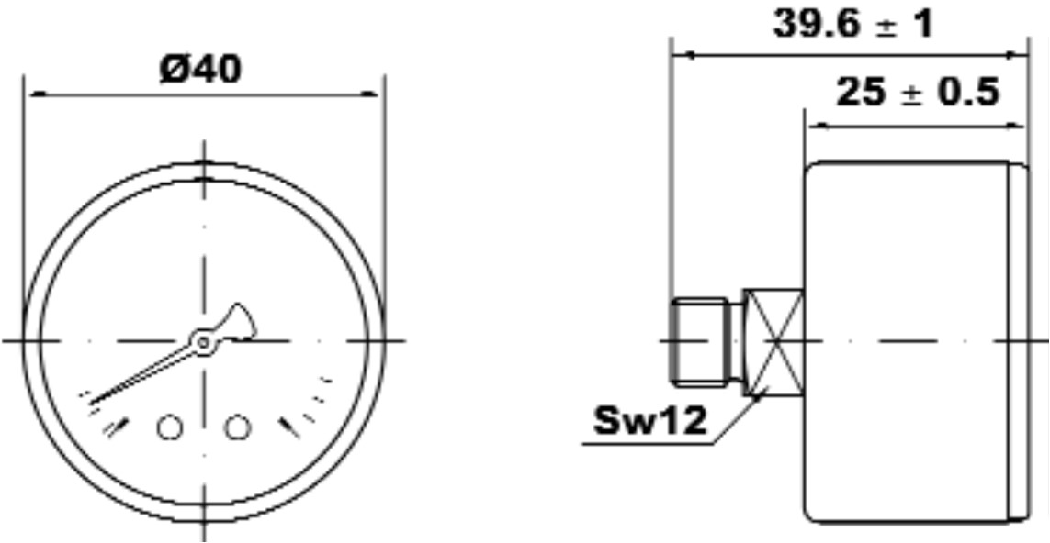*

### M008-R00-VS

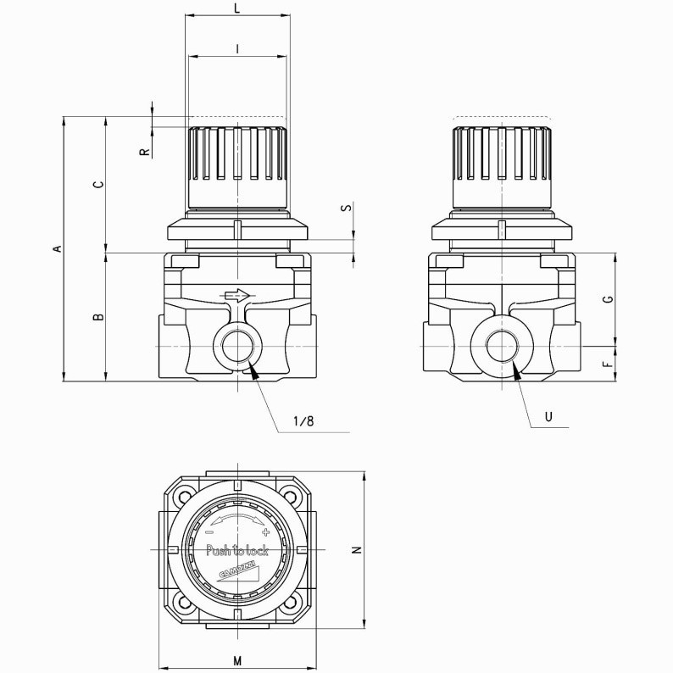

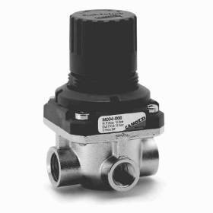General characteristics

Constructive type With membrane Materials body: steel INOX; O-ring:

NBR

Fitting G1/8 - G1/4

Weight Kg 0,235 Working Temperature-5°C ÷ 50°C Entry pressure 0 ÷ 16 bar

Exit pressure 0,5 ÷ 10 bar

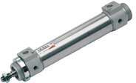**Cylinders Series 42**

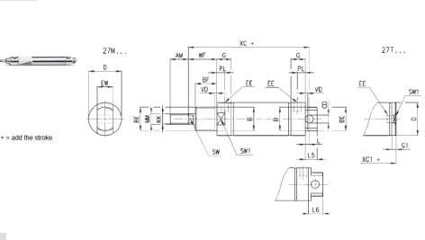

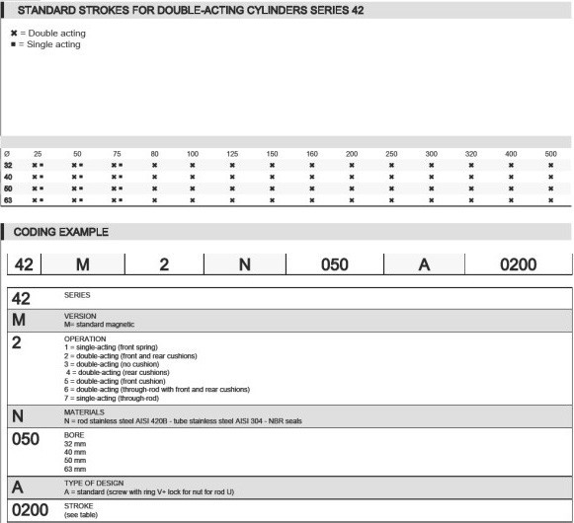

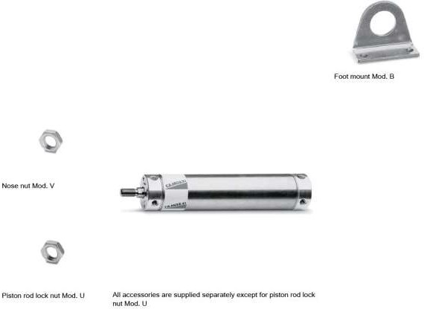

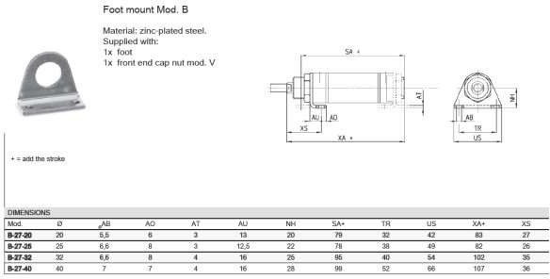

## Aspects of automatisation

The demonstrative stand was made for gaining access to data in coordinate movement of the stepper motor, transmission and pistons.

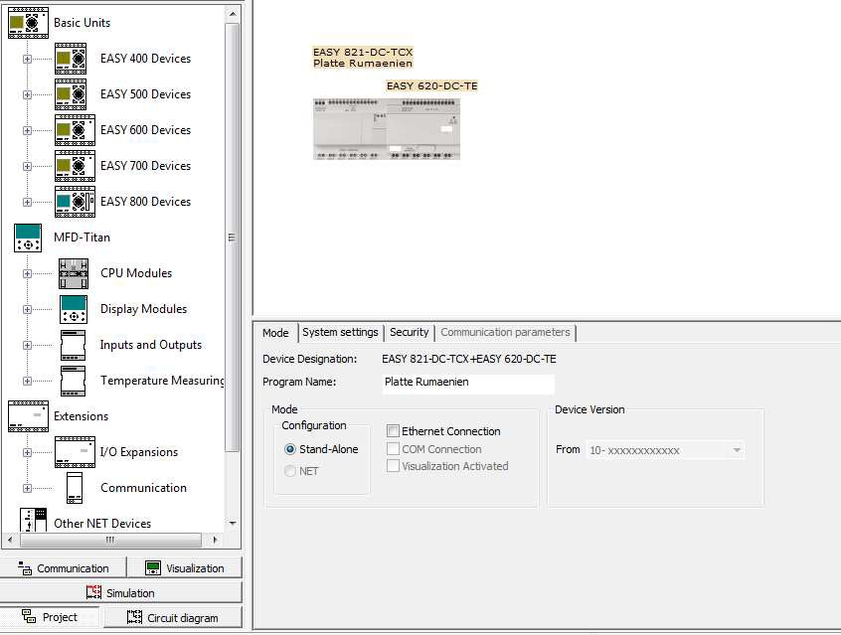

The parameters of the movement have been processed with Easy soft 6.

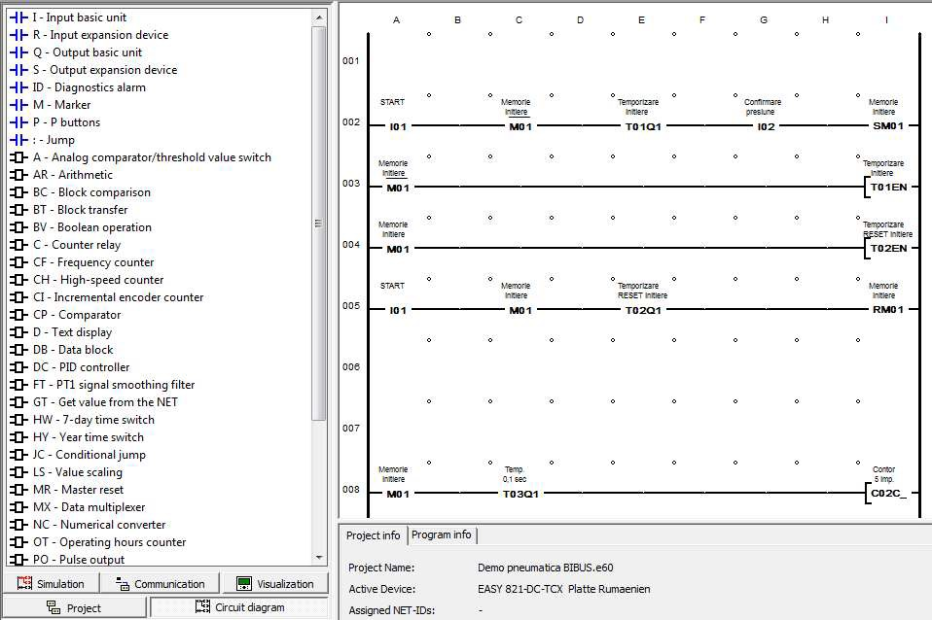

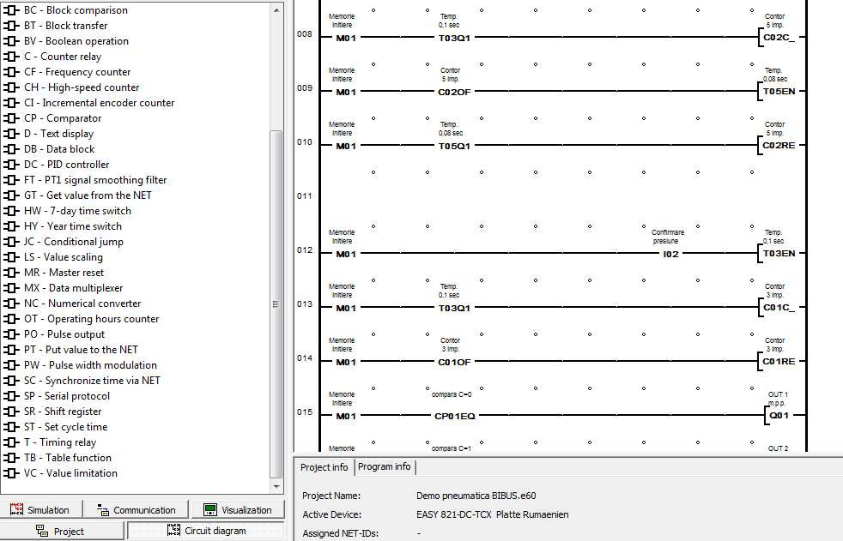

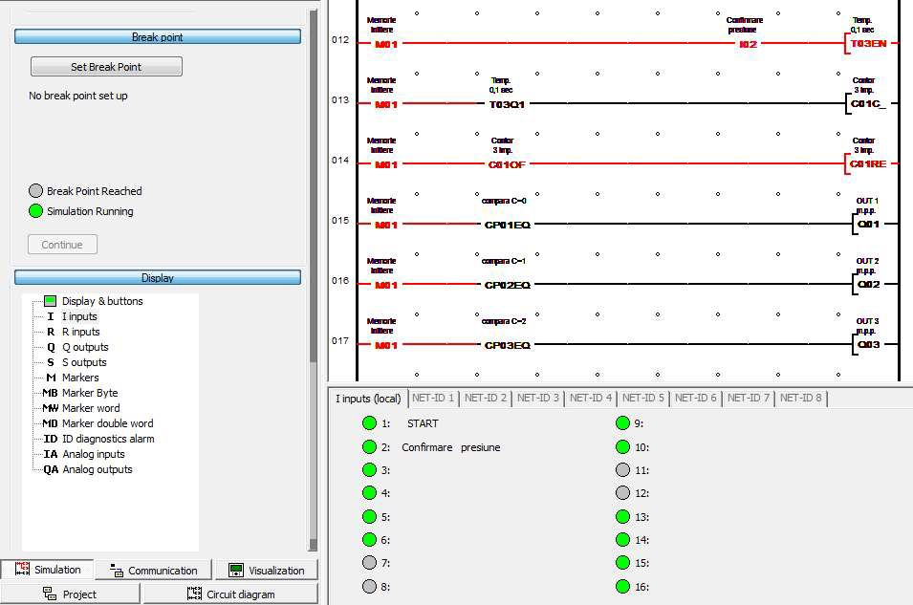

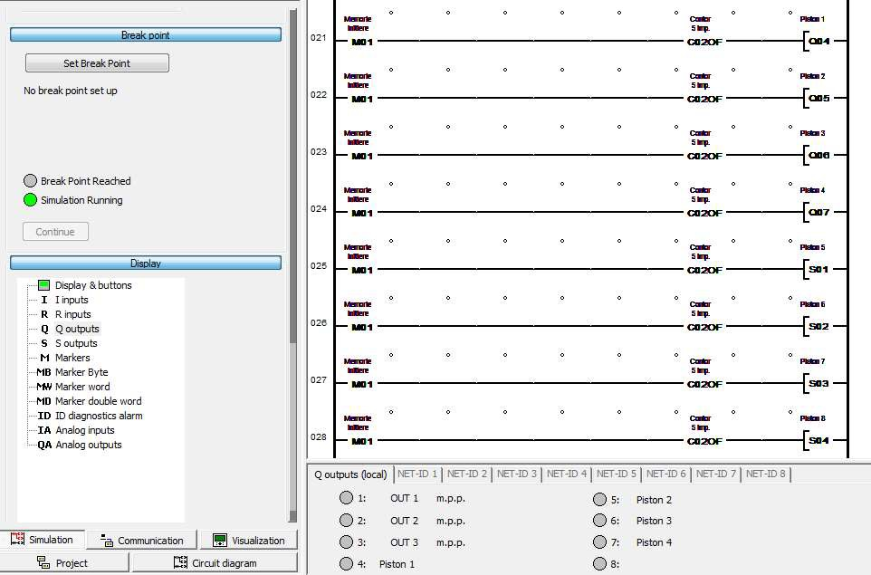

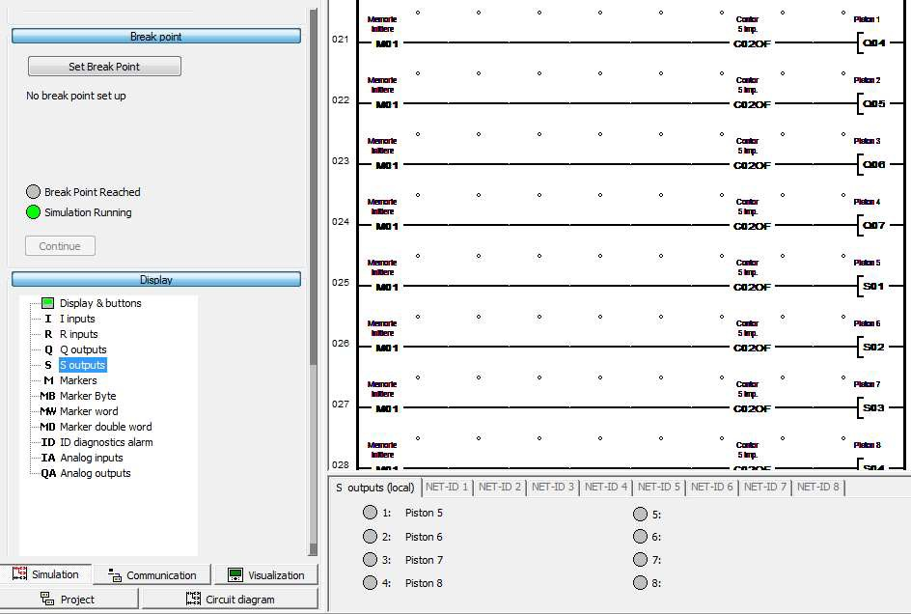

The automatization for the demonstrative stand implies 3 steps:

First is checking pressure and control;

Second, creates movement for pistons, all together must coexist in a union translation to approach the destined slot in center –wheel;

And the third step is specific for the rotation of the wheel, making successive angular rotation just enough for the pistons to perfectly align without damaging the wheel.



## Detailed presentation of the equipment

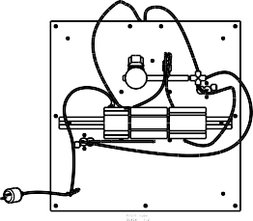

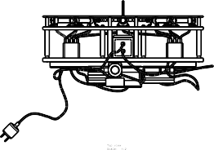

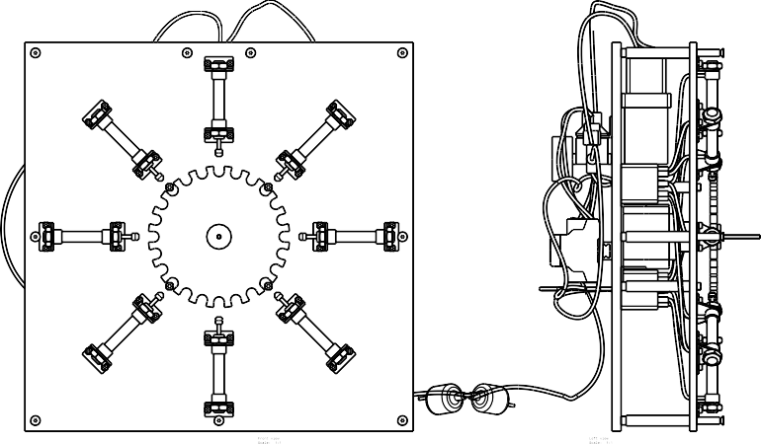

Demonstrative stand without first Plexiglas

